1. **Create one jenkins job using the below code and create three stages.**

**stage1: Git clone to download the source code.**

**stage2: Sonarqube Integration to check the quality of code**

**stage3: Slack Integration to send the alerts to slack. URL:** [**https://github.com/betawins/VProfile-1.git**](https://github.com/betawins/VProfile-1.git)

**launch ec2 instance with t2 large and 20 gb install java in the same**

**“yum install java-1.8* -y” as the code supports only 1.8 as of now**

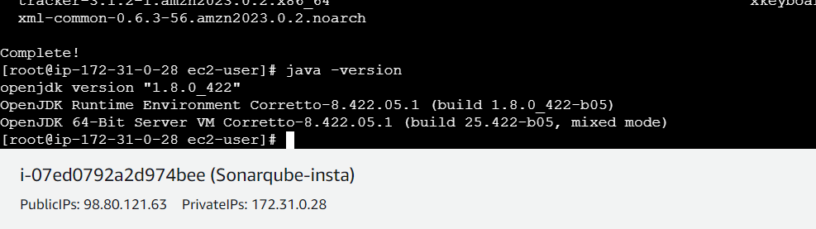

**Now install my sql**

**sudo wget** [**https://dev.mysql.com/get/mysql80-community-release-el9-1.noarch.rpm**](https://dev.mysql.com/get/mysql80-community-release-el9-1.noarch.rpm)

**sudo dnf install mysql80-community-release-el9-1.noarch.rpm –y**

sudo yum install --nogpgcheck mysql-community-server

sudo systemctl start mysqld

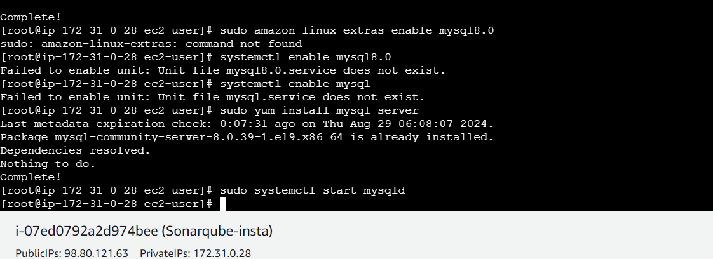

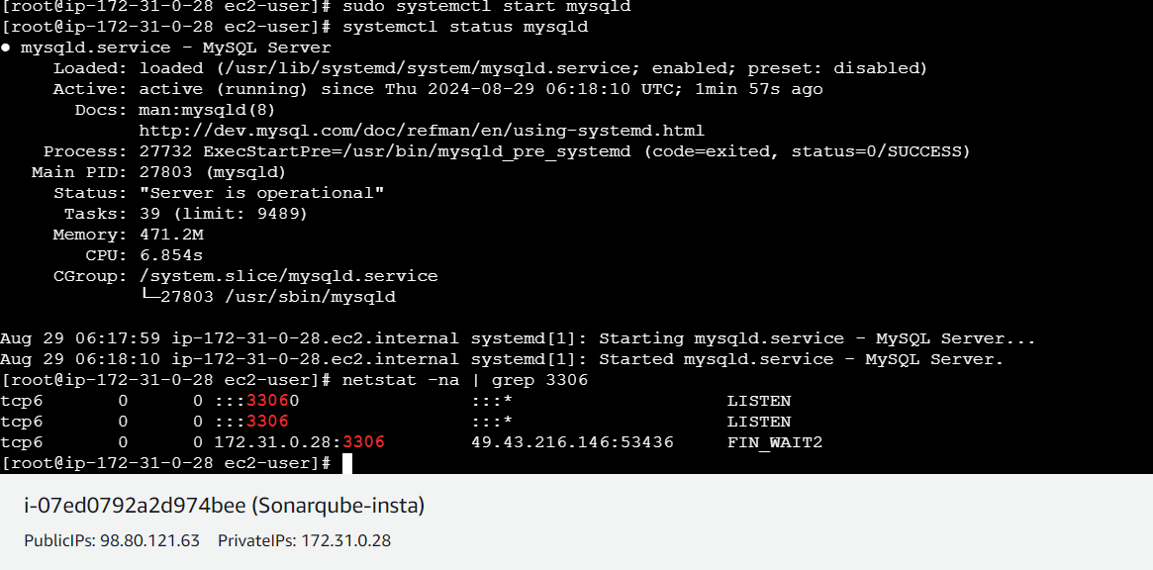

**Create password using**

**grep ‘temporary’ /var/log/mysqld.log**

**now login and chage password**

**mysql –u root –p**

**after entering**

**ALTER USER ‘root’ @ ‘localhost’ IDENTIFIED BY ’Admin@123’;**

**Flush privileges; >> to update previliges**



**Cutom password create**

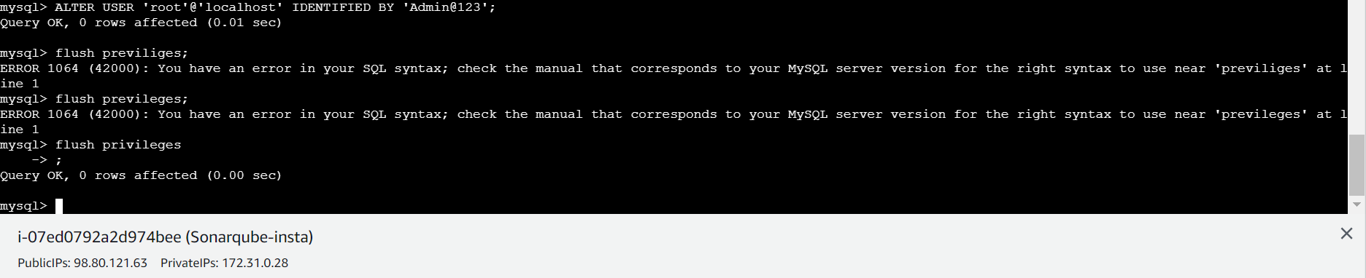

**Opening with new password Admin@123**

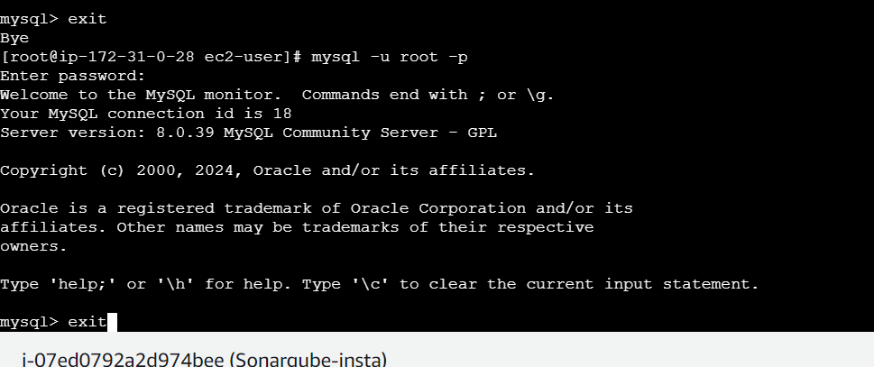

**Now exit and install sonarqube**

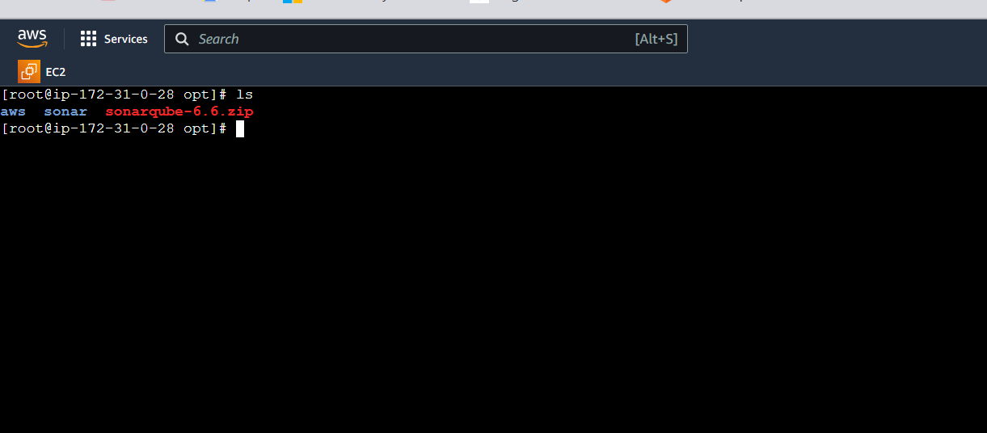

**Commands:-**

# cd /opt

# wget https://binaries.sonarsource.com/Distribution/sonarqube/sonarqube-6.6.zip

# unzip sonarqube-6.6.zip

# mv /opt/sonarqube-6.6 /opt/sonar

**Created a database called sonar**

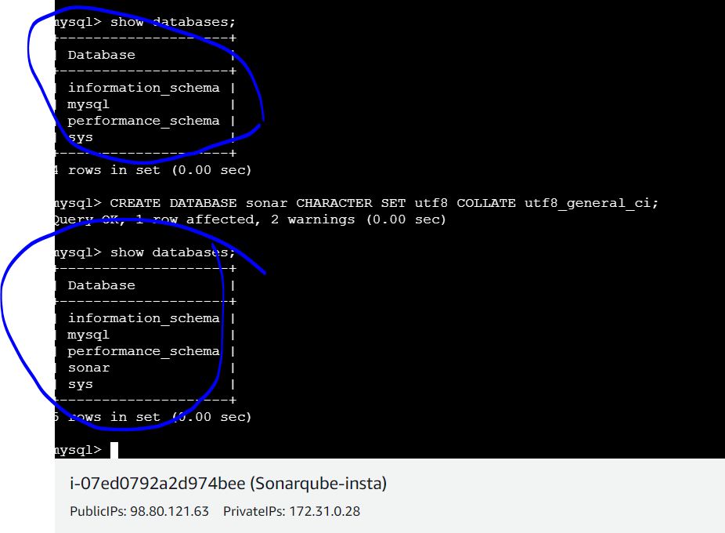

**Create users**

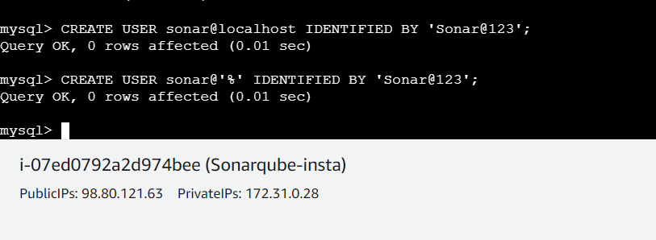

**Add permissions**

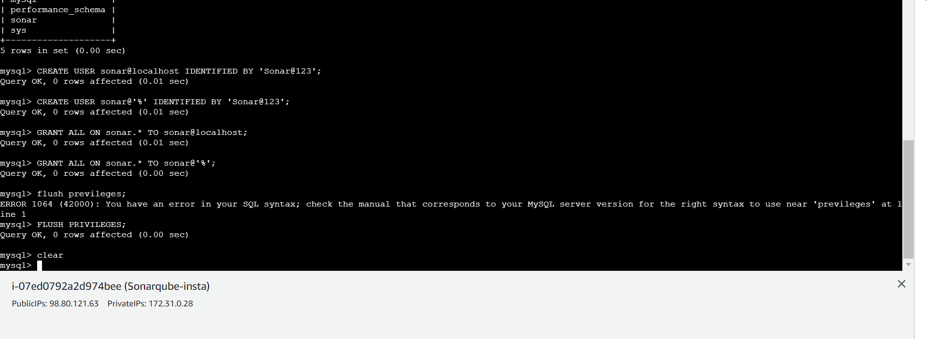

**Exit and start sonarqube now**

**Change sonar properties**

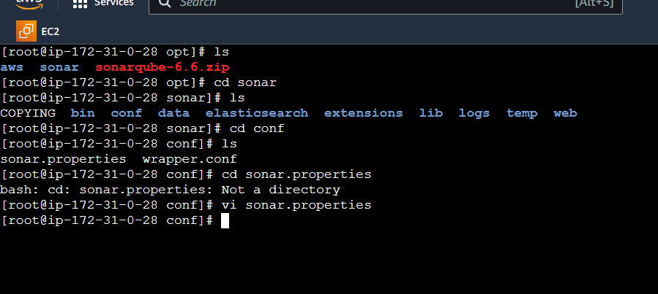

**Start sonar qube afer all changes go to cd /opt/sonar/bin/linu-x84-64**

**./sonar.sh start**

**Check owner ship change to chown ec2-user:ec2-user sonar**

**Sudo ./sonar.sh start**

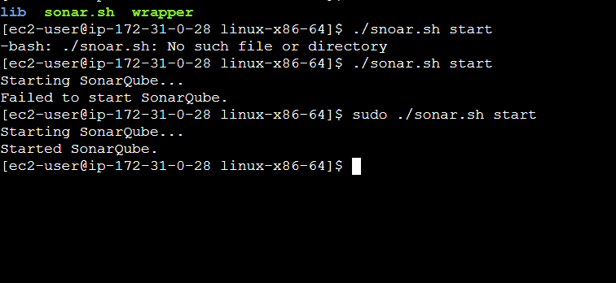

**Check logs any issue**

**Now check in browser using 9000 and /sonar which u gave in sonar properties**

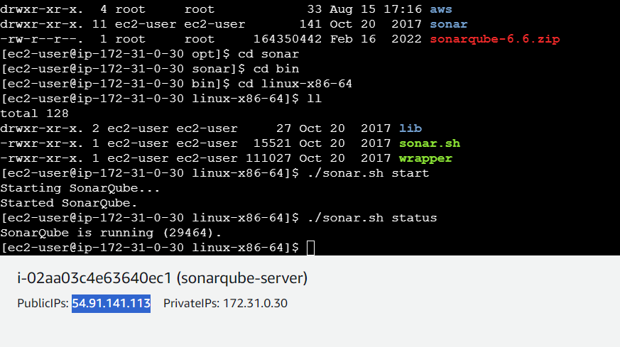

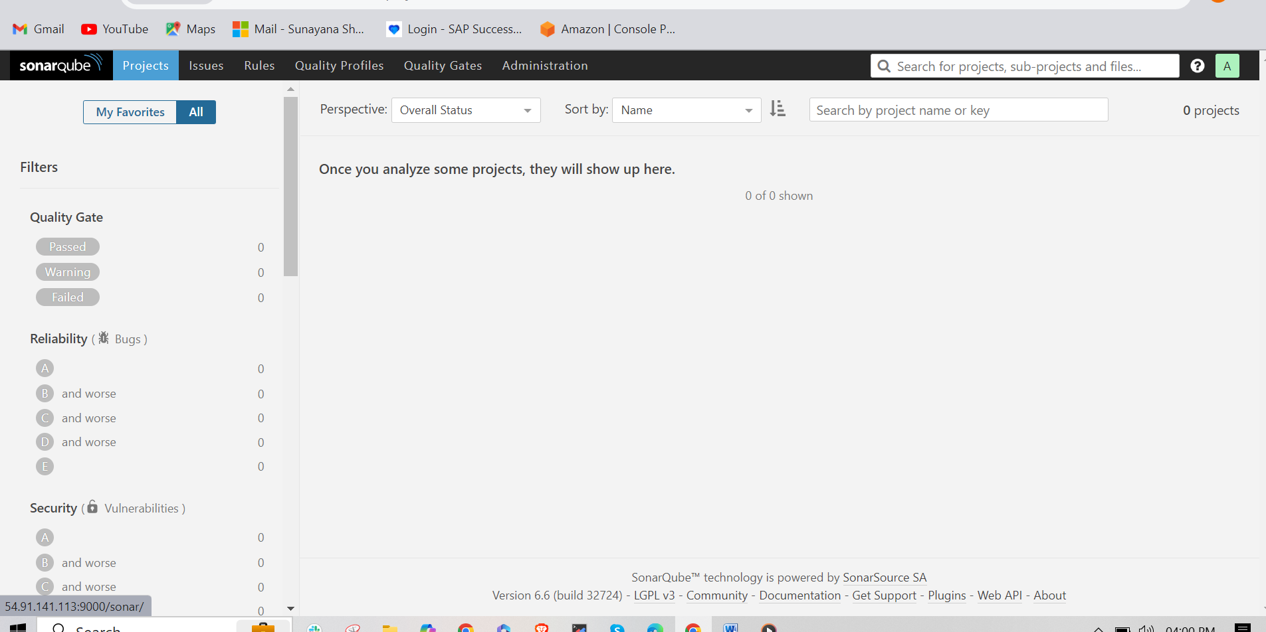

**Install sonarqube scanner and it will appear in buil actions**

**Now,create a token in sonarqube**

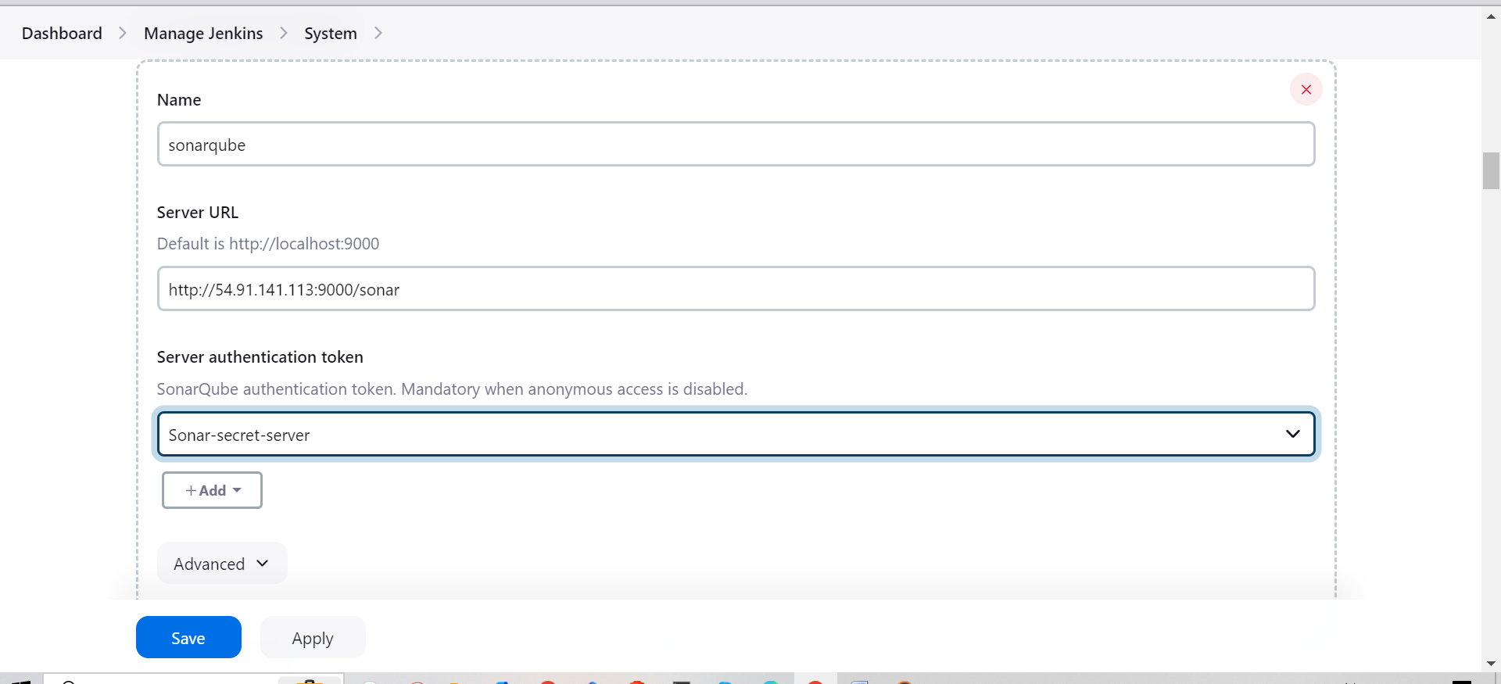

**Successfully integrated sonarqube**

**Go to gui and pass sonar scanner path**

**Gui>>manage Jenkins>> tools**

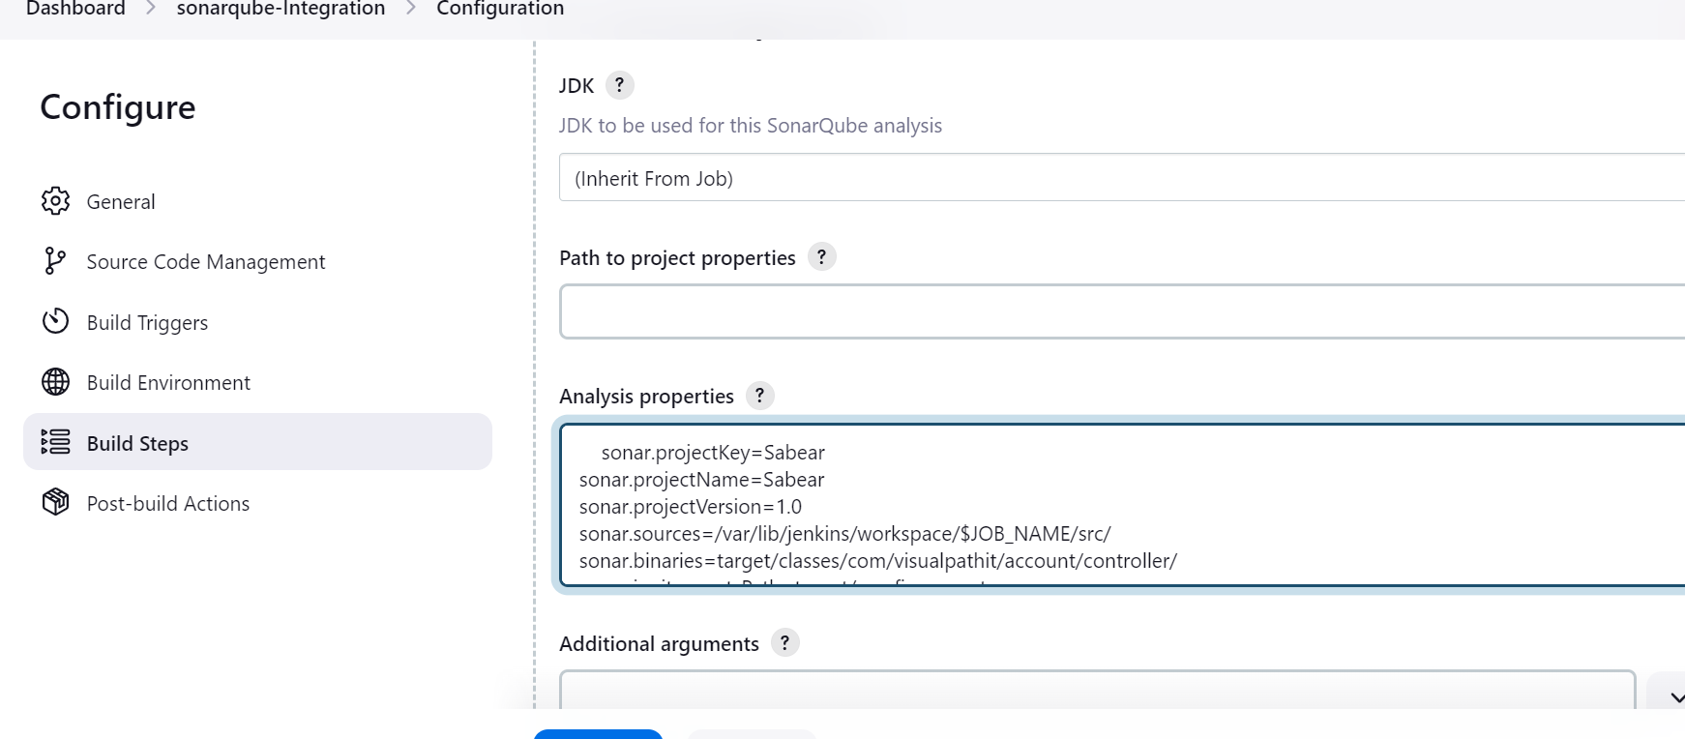

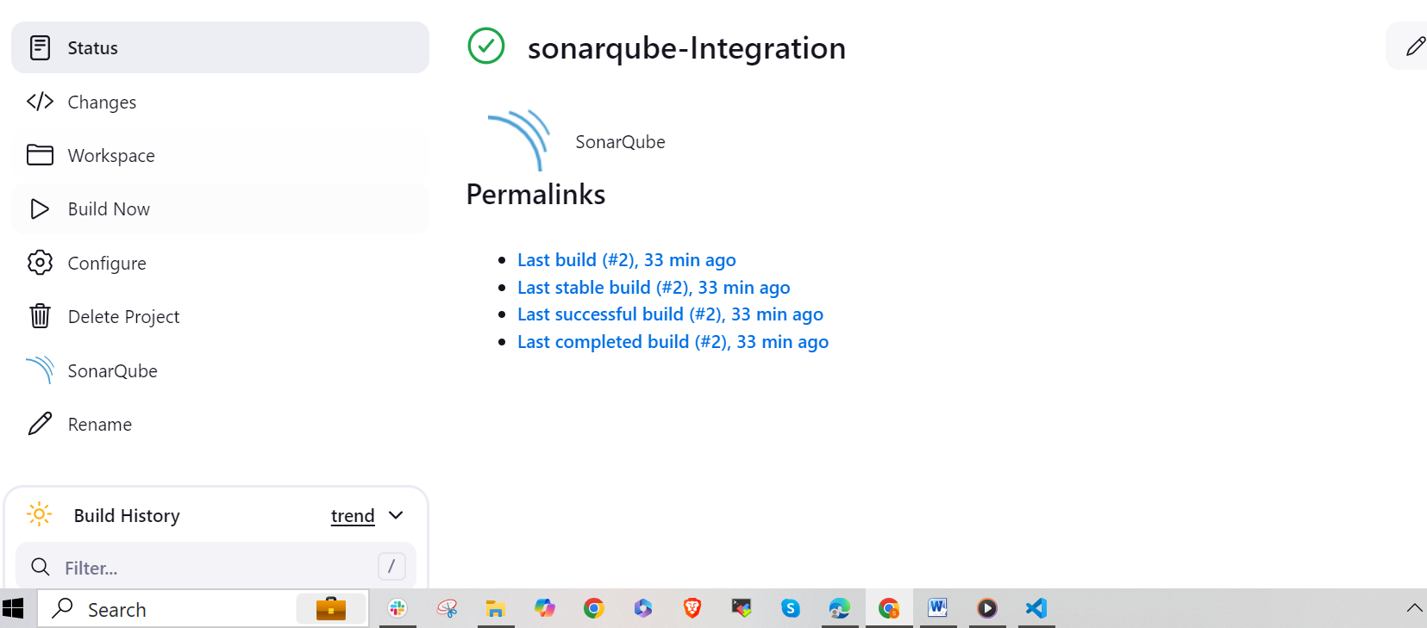

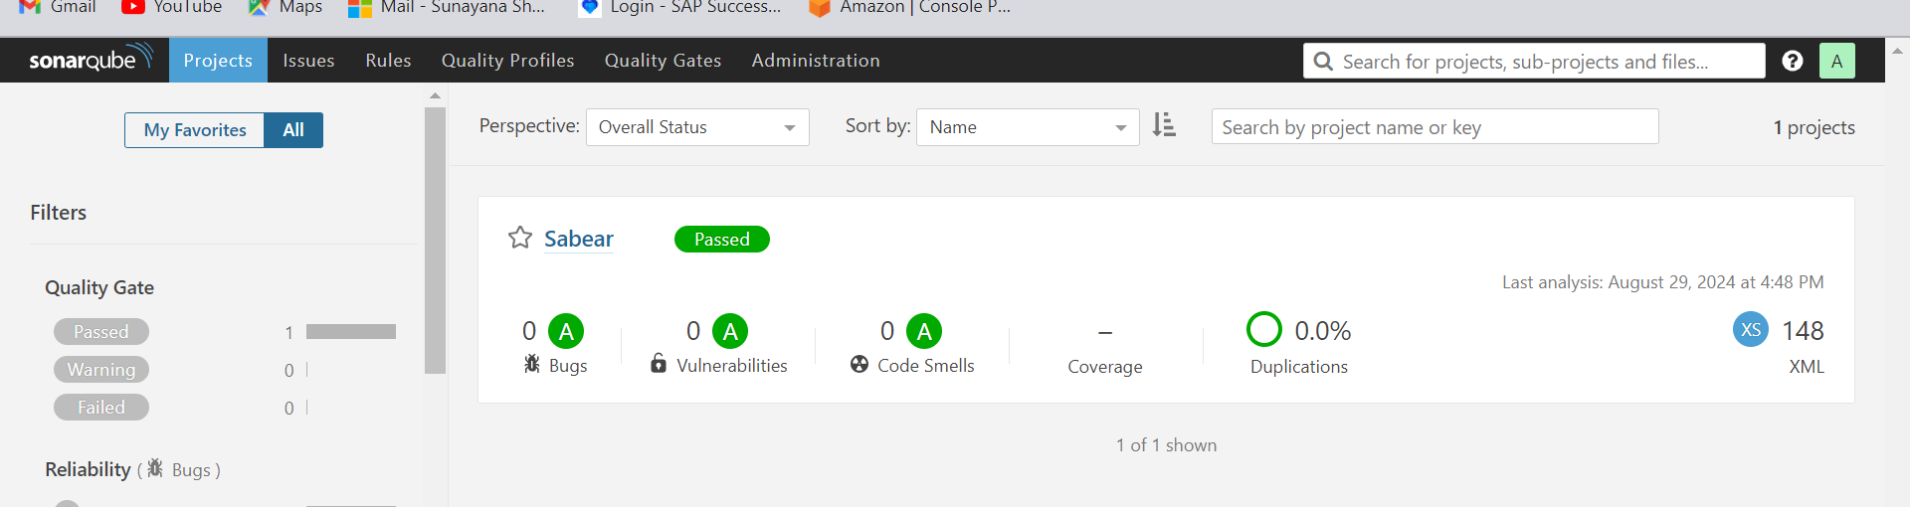

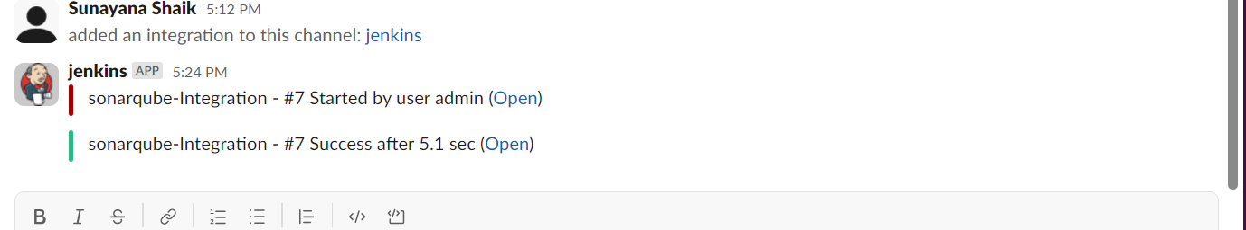

**Install docker**

**Start docker**

**Docker pull sonarqube**

**Docker pull**

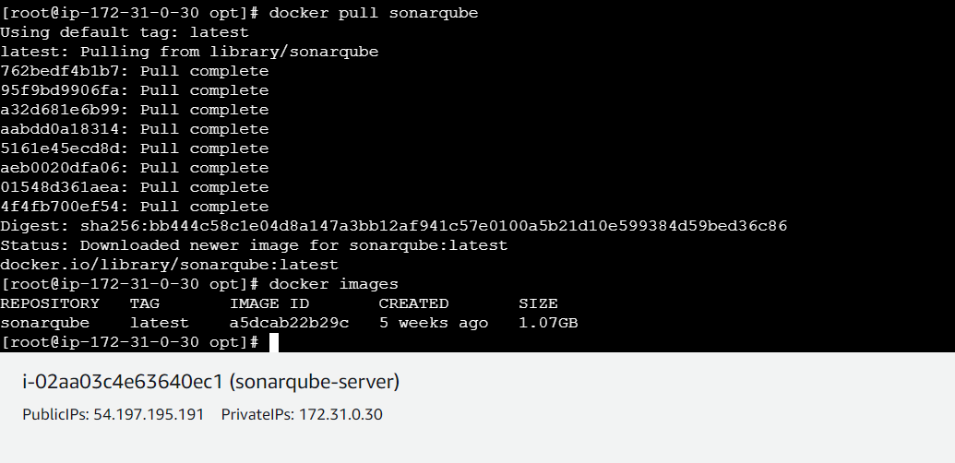

**Sonarqube starting with 9002**

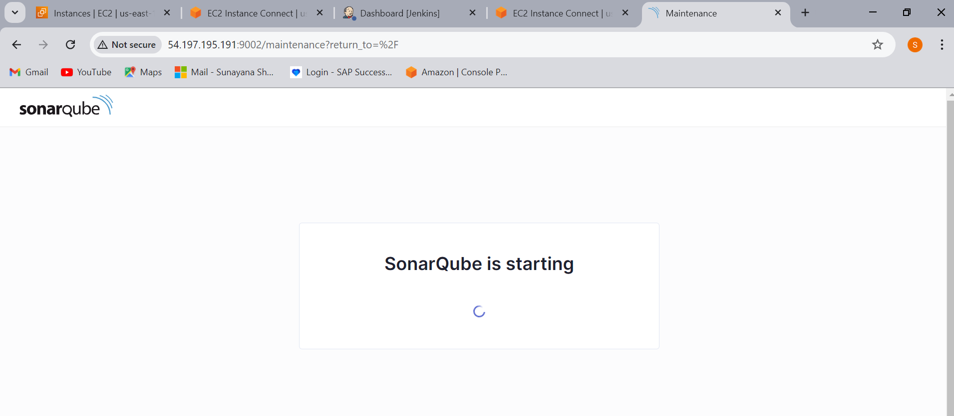

**docker run –itd –p 9002:9000 sonarqube**

